09.10.2018

Dear student,

Warm greetings of the Day!

**SCHEDULE OF WORKSHOP ON MOOTING**

Mooting as an activity aims to inculcate and improve the research, presentation and argument talent in students so as to equip the budding pleaders with all the court room etiquette, research experience and advocacy skills. At Lloyd it is a key co-curricular activity wherein the presentation skills and talents in argument of students are screened and further notified about their level in the competition on regular basis. This initiative is well supported and effectively carried out by a dedicated Moot Court Society.

Moot Court prepares students to participate in simulated court proceedings. It includes drafting of brief/memorial and further participation in oral argument before the Judges in the courtroom atmosphere. It does not involve actual testimony by witnesses or the presentation of evidence, but is focused solely on the application of the law to a common set of evidentiary assumptions/situations. Students typically spend lot of time during the semester researching and writing the memorials, as well as practicing their oral arguments.

**IME**is the ‘Internal Selection’ round of contestants from amongst BA.LL.B. and LL.B. students to represent Lloyd in all External Moot Court Competitions (International Law Mooting Competitions) during 2018-19. This time we are holding the event on **Sunday 21 Oct. 2018, 09:00**.

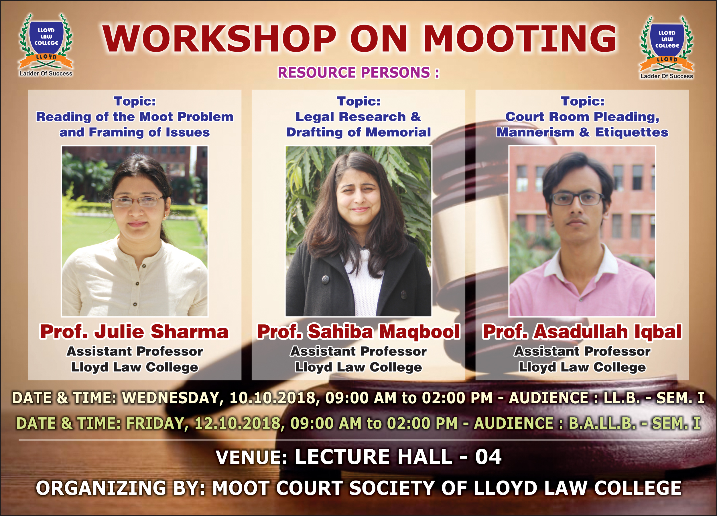

Moot Court Society, Lloyd Law College is organizing “Workshop on Mooting” on Wednesday - 10.10.2018 for LL.B. 1st Year and on Friday - 12.10.2018 for B.A.LL.B. 1st year. This “Workshop on Mooting” will expose the first year law students to the concept of mooting and thus, lay foundation on the fundamentals of mooting. This is an invite and inform to all the LL.B. - Sem. I & BA.LL.B. - Sem. I students to participate in the Mooting Training Workshop on their designated dates.

This “Workshop on Mooting” will be based on the Moot Compromis of 18th Henry Dunant Memorial Moot Court Competition, 2018. This is an international law problem and will allow the aspirants of IME to understand the fundamentals of participating in an international law moot court.

**IMPORTANT NOTE:**

1. The Moot Compromis is attached with this email. All the participants of the workshop are requested to read the Moot Compromis in advance and if possible carry a hard copy of the same.
2. There shall be no regular classes/attendance for the Batches on the designated Workshop days. Those students who are not interested in Mooting are permitted to be absent on their scheduled moot workshop days.

Feel free to contact in any further regard,

**Dr. Md. Salim**

**Director**

**LLOYD LAW COLLEGE**

[director.lloydlawcollege.edu.in](http://www.lloydlawcollege.edu.in)